PROJECT NAME : AMAZON SHOPPING
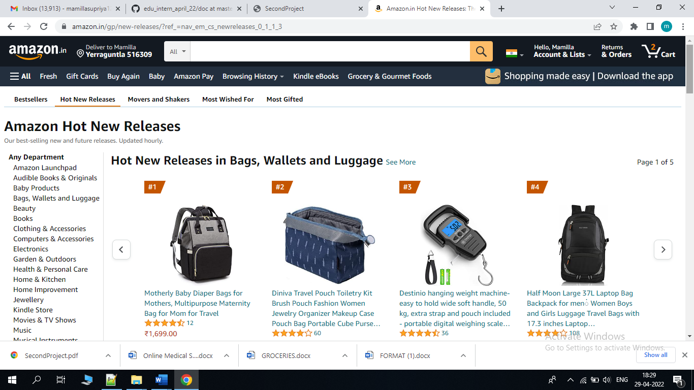

SUPRIYA MAMILLA
Edureka presents

Overview Of My Project :
The Amazon app conveniently allows you to shop and pay across a wide selection of products and categories at great prices, all within a single app. We can Shop electronics, fashion, household items & even grocery items more with the online shopping app.
Goals :
- Registration / Login Page
- Subscription page
- Home page
- Payment page
- Logout page
Technologies to be used :
- Front-End :
1. Html
2. Css
3.Bootstrap
4.ReactJS
- Dynamic:
1. Javascript
2. ReactJS
- Backend :
1.NodeJS
2.ExpressJS
- Database :
1. Mongodb
- Code compilers:
1. Visual studio code
2. Node js.

UI DIAGRAM :
